Exadata_cloud_Infrastructure with ORM stack

Contents

1. Introduction 3
2. Workflow diagram to deploy the stack 3
3. Create stack for Exadata cloud Infrastructure 4
4. Plan the Job 8

Introduction

Exadata Cloud Infrastructure allows to leverage the combined capaibilities of Oracle Exadata and Oracle Cloud Infrastructure.

Workflow diagram to deploy the stack

Below diagram shows how the Terraform Artifact are applied in the OCI. While creating a ORM stack, using terraform deliverables Init, Plan and Apply is the flow to provision the resource in the OCI. We can have the deliverables in any of below.

- Git Lab/GitHub Repo
- Bit bucket
- Can be in folder/.zip in the local disk
- Object Storage Bucket
- Can be in compartment
- Oracle provided Template


Create stack for Exadata cloud Infrastructure

Go to OCI Console Developer Services Resource Manager Stacks select the compartment Create Stack

My Configuration Folder Browse Select the “exadata_vm_clusters” folder that contains the terraform Upload

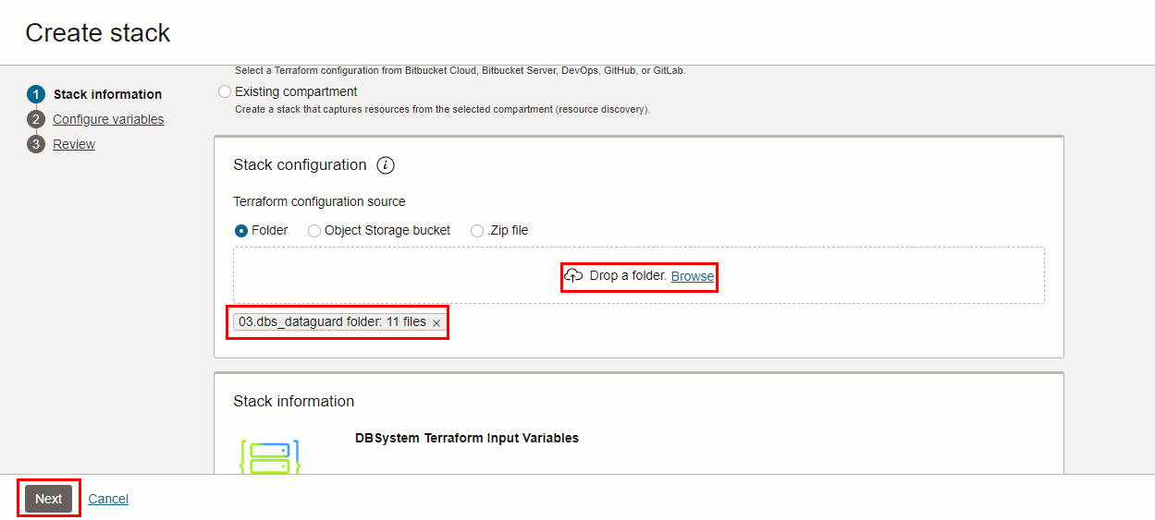

Select the parameters as per the below screen,

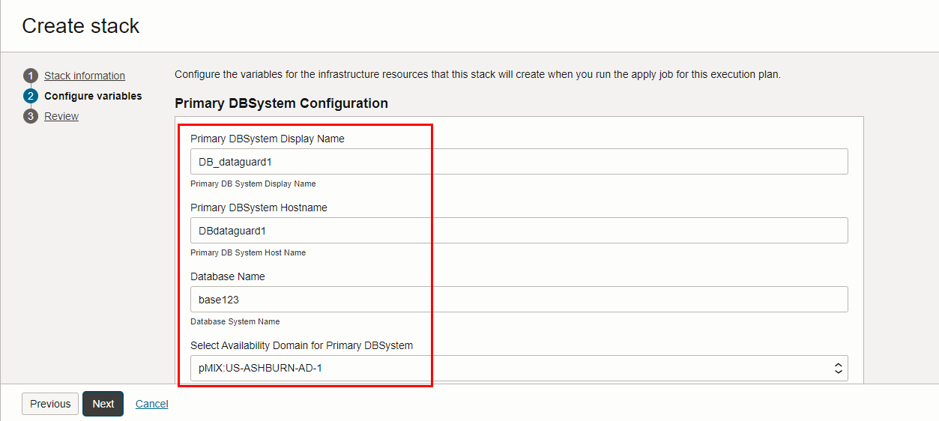

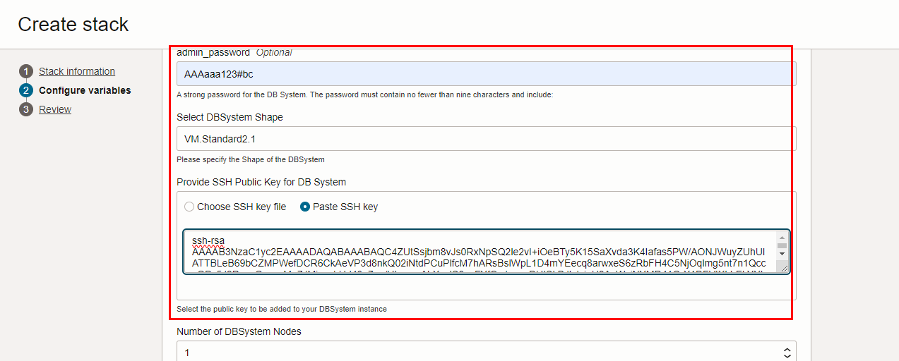
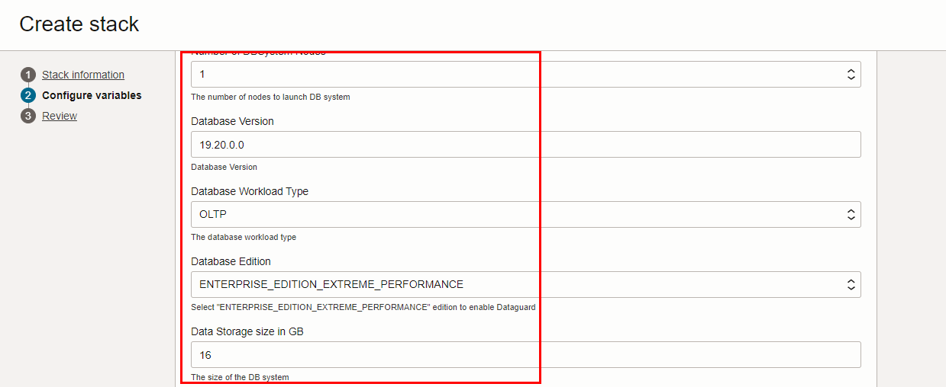

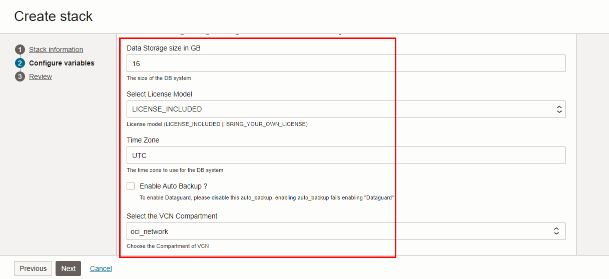

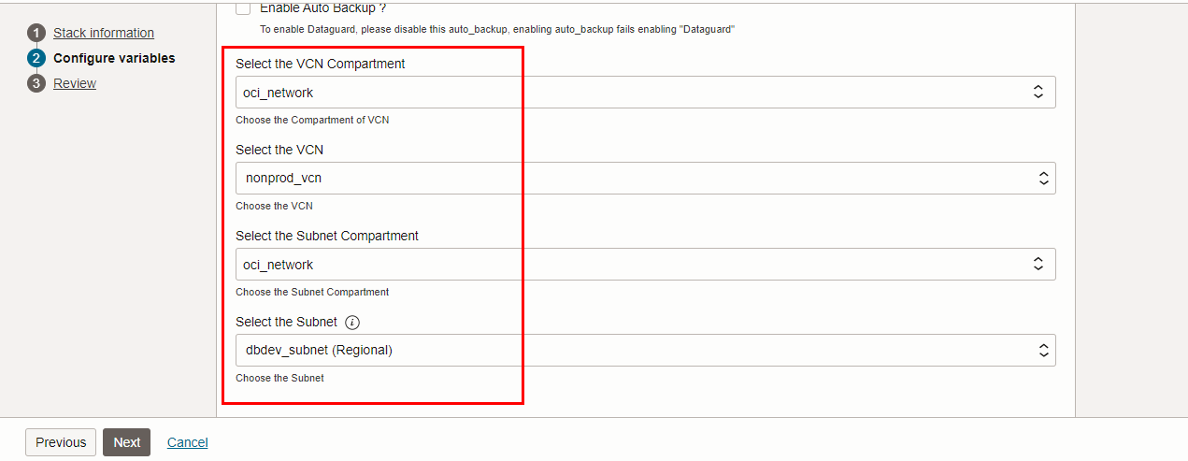

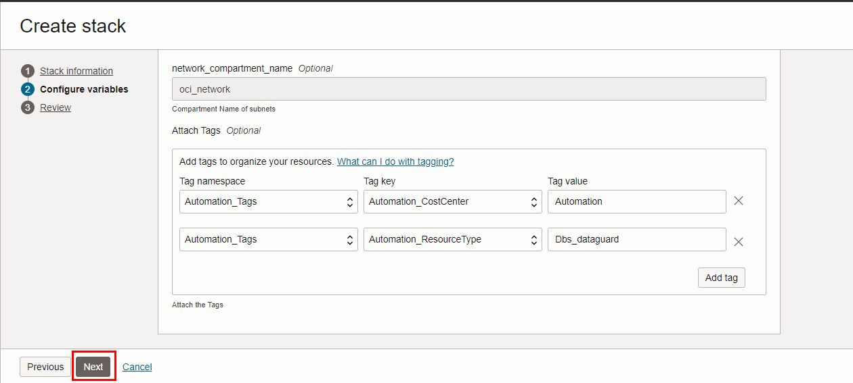

Click “NEXT”
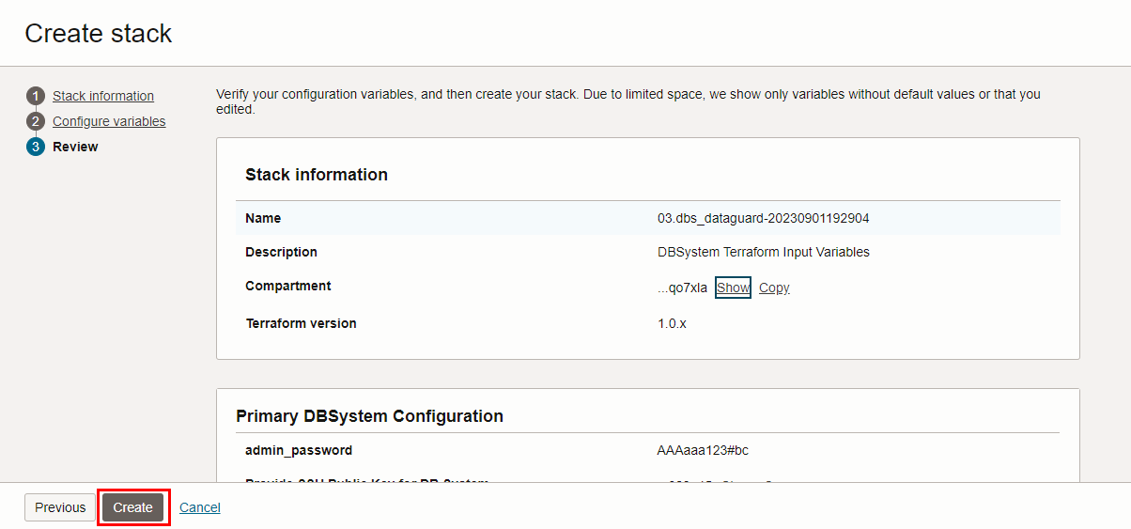
Click “CREATE”

Plan the Job

Click the “Plan”
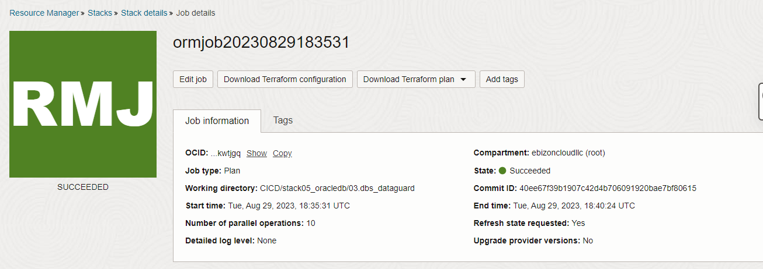

#END#

